***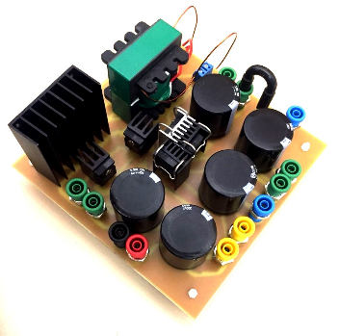***

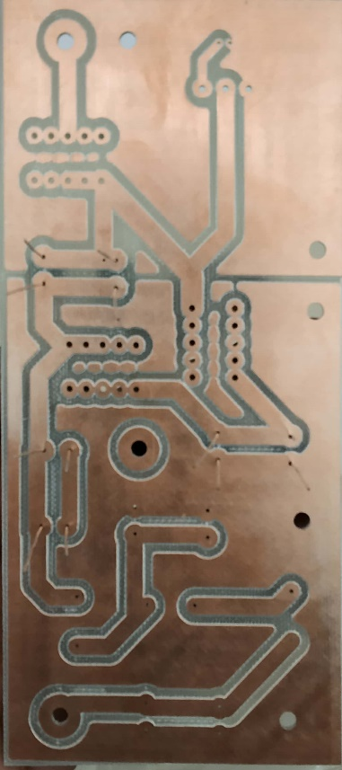

|  |  |
| --- | --- |
| **Components** | |
| **Inductor (L1, L2 and L3)**  100 μH, 15 A | C:\Users\ARYA\Desktop\IMG_20181013_134552.jpg |
| **Capacitor (C1, C2 and C3)**  2.2 μF, 450 V  (two capacitor connected in parallel to achieve 5 μF) | C:\Users\ARYA\Desktop\IMG_20181013_134402.jpg |
| **Diodes (D1, D2 and D3)**  (STTH6012W)  (1200 V, 60 A) | C:\Users\ARYA\AppData\Local\Microsoft\Windows\INetCache\Content.Word\New Doc 2018-10-14 10.49.56_1.jpg |
| **Silicon Carbide Power MOSFET**  (**C2M0160120D)**  VDS: 1200 V  ID: 19 A  RDS(on): 160 mΩ | C:\Users\ARYA\Desktop\IMG_20181013_134510.jpg |

Banana caps as terminal (low resistance) for connecting DC supply and load.

**Hardware Implementation of Inverting Nx Converter for Three levels (15 V to -105 V conversions with 100W)**

**Power Circuitry:**

**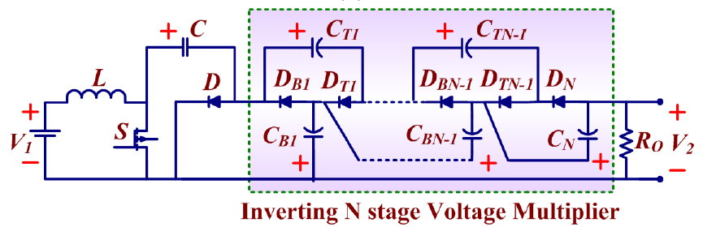**

**Hardware Implementation:**

**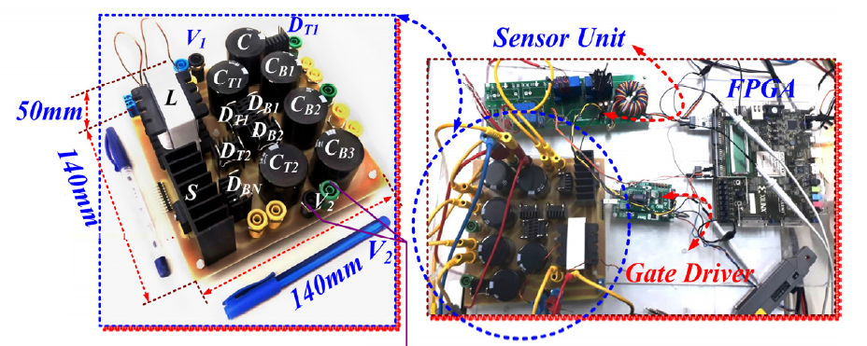**

|  |
| --- |
| 1. **Inductor (L)**   **Core type inductor is designed by self. The inductance rating is in between 100uH to 200uH and 10A copper wire is used. Prototype is tested at 100uH by adjusting the turns.** |
| 1. **Capacitors: Electrolyte Type- 330uF, 450V**   **(Higher voltage rating is used for future investigation)**  Image result for 330uF, 450V |
| 1. **Diodes**     **Datasheet:** [**https://www.st.com/resource/en/datasheet/stth6012.pdf**](https://www.st.com/resource/en/datasheet/stth6012.pdf) |
| 1. **Silicon Carbide Power MOSFET (C2M0160120D)**       **Datasheet:** [**https://www.wolfspeed.com/media/downloads/169/C2M0160120D.pdf**](https://www.wolfspeed.com/media/downloads/169/C2M0160120D.pdf) |
| 1. **FPGA- Virtex 5 is used to generate Control Pulses along with sensor.** 2. **Gate Driver: Made by Taraz Technologies (GDA Advanced Series) More detial avaiblae on** [**https://www.taraztechnologies.com/products/power-electronics-modules/gate-driver-boards/**](https://www.taraztechnologies.com/products/power-electronics-modules/gate-driver-boards/) |

1. **Heat Sink –Flat Type**

**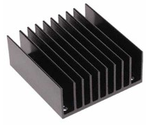 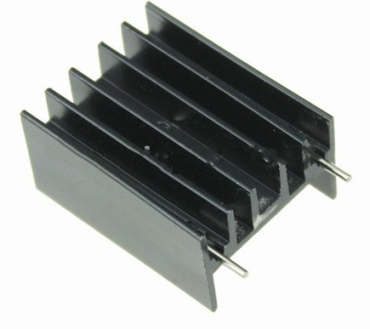**

**Used for MOSFET Used for Diode**

[**http://www.lpkfusa.com/datasheets/prototyping/s62.pdf**](http://www.lpkfusa.com/datasheets/prototyping/s62.pdf)